Project 16: Line Tracking Smart Car

1. Description
The car comes with two line tracking sensors and two potentiometers.
Besides, it adopts a TCRT5000 IR tube, which contains an IR emitting tube and an IR receiving tube. When the infrared signals of the emitting tube is received by the receiving tube through reflection, the resistance of the receiving tube will change, which is generally reflected in the voltage change on the circuit.
The resistance varies depending on the intensity of the infrared signals received by the receiving tube, which is often in the color of the reflecting surface and its distance of the receiving tube. At the time of detection, black is high level active and white is low level active.
Working Principle: When the car runs above a white road, the IR emitting tube installed under the car emits infrared signals to detect the road and the receiving tube will receive signals sending back. Then the output end outputs low level(0). When it detects black lines, it outputs high level(1).

Send the detected signal to the I/O port of the microcontroller. When it is high level (1), then the car is on the black line. Similarly, when it is low level (0), then the car is on the white ground.

The two line tracking sensors on the expansion board are controlled by P12 and P13 of the micro bit control board, the left one is controlled by P13, and the right is controlled by P12. Adjust the line tracking sensors, and place the car on a black ground, twist the potentiometers until the LED (D3,D2) is on, then adjust them until it is off.

2. Preparation
（1）Insert the micro: bit correctly into the expansion board
（2）Connect the battery holder to the expansion board
（3）Turn on the power switch（Slide the POWER switch to ON end）
（4）Connect the micro：bit and computer via a micro USB cable
（5）Open the Web version of Makecode
If you want to add the Mini car extension library(you can refer to the "1. Development environment configuration "file).

3. Circuit Diagram

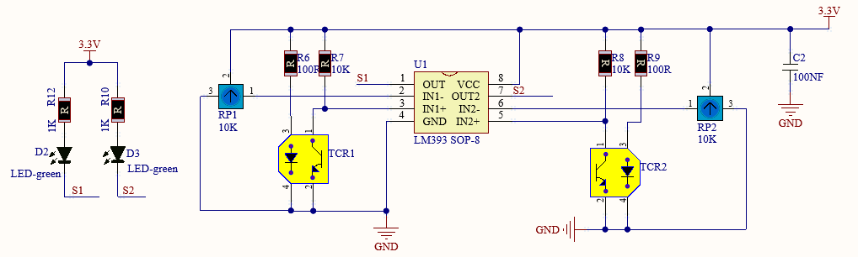

4. Read the Line Tracking Sensor
You can upload the code “code_1.py”directly from the tutorial (read the "Development Environment Configuration" file if in doubt).
Code 1:
from microbit import *
pin12.set_pull(pin12.PULL_UP)
pin13.set_pull(pin13.PULL_UP)
sensor_L = 0
sensor_R = 0

while True:
sensor_L = pin13.read_digital()
sensor_R = pin12.read_digital()
print("sensor_L:", sensor_L)
print("sensor_R:", sensor_R)
sleep(1000)
Test Result: Download code 1 onto micro:bit board, don’t plug off USB cable. Click“REPL”and press the reset button, the readings detected by the line tracking sensor will be displayed on monitor.
When the line tracking sensor detects white object, 0 will be shown and D2, D3 will be on; when no white objects and only black object are detected, 1 will be displayed and D2, D3 will be off, as shown below.

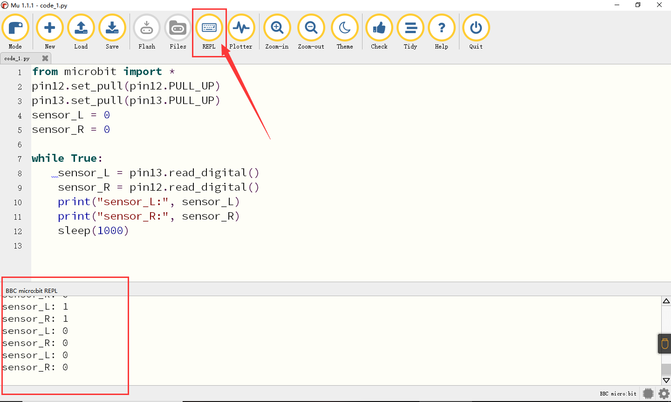

5. Flow Chart
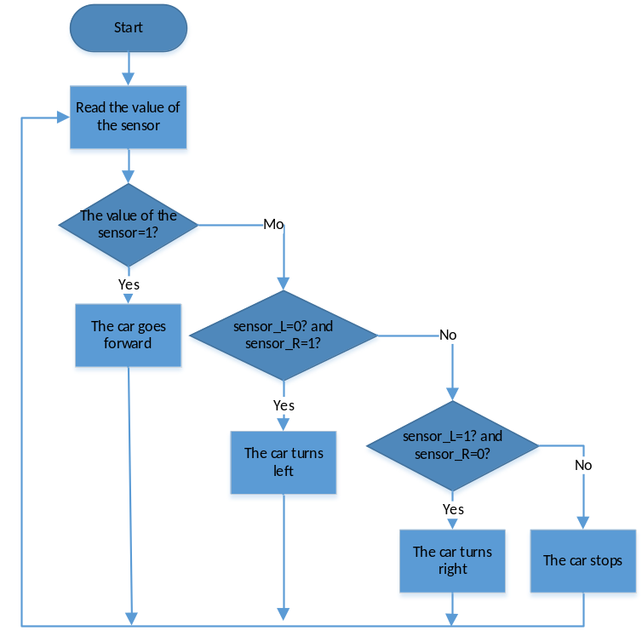

6. Test Code:
You can upload the code “code_2.py”directly from the tutorial (read the "Development Environment Configuration" file if in doubt).
Code 2:
from microbit import *
from keyes_MiniCar import * #Import the library file
minicar = MiniCar() #Instantiate an object MiniCar（）as minicar
pin12.set_pull(pin12.PULL_UP) #Set pin12 to pull up
pin13.set_pull(pin13.PULL_UP)
sensor_L = 0
sensor_R = 0

while True:
sensor_L = pin13.read_digital() #Read the value of the sensor
sensor_R = pin12.read_digital()
print("sensor_L:", sensor_L)
print("sensor_R:", sensor_R)
if sensor_L == 1 and sensor_R == 1: #Judge if sensor_L and sensor_R =1
minicar.Motor_L(1, 70) #Advance code
minicar.Motor_R(1, 70)
elif sensor_L == 0 and sensor_R == 1: #Judge if sensor_L =0 and sensor_R=1
minicar.Motor_L(1, 70) #Right turn code
minicar.Motor_R(0, 70)
elif sensor_L == 1 and sensor_R == 0: #Judge if sensor_L=1 and sensor_R=0
minicar.Motor_L(0, 70)
minicar.Motor_R(1, 70)
else:
minicar.Motor_stop()

Test Result: Upload the code 2 and open the power switch on the car. Place the car on the line tracking paper, then it will follow the black line to move.

